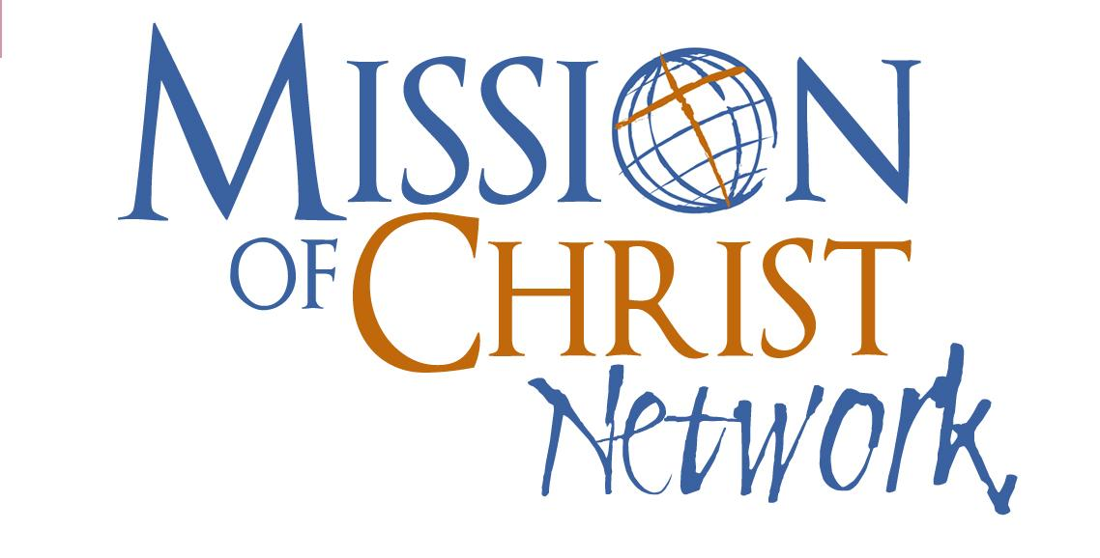
Field Guide Welcome:

General Photo / Social Media Guidelines:
Use these three list items to evaluate the story your photos are telling. Before you post to social media about this trip, ask yourself, does this photo show…

- Mission? Take photos that show God’s work being done, especially when it is accomplished by nationals. Focus on the big picture of God’s work, not simply on your part in His mission. Where can you see the Gospel being shared and the love of Christ being shown in this place?
- Honor? Take photos that those who are being photographed would be proud of. Luther on the 8th commandment says of our neighbor that we should “defend him, speak well of him, and explain everything in the kindest way.” The old adage is, "a picture is worth a thousand words.”
- Relationships? Take photos that illustrate healthy relationships people have with our God and also with one another. Take fewer selfies and more shots of people interacting in meaningful ways.

Information about the Ministry:

- What partner churches, schools, and organizations will teams be interacting with? Provide a background of the local ministry as well as a brief history of MCN’s partnership and involvement:

- What missionaries are on the ground? Provide a profile for each member of the ministry staff as well as local pastors and other key leaders in the community. Follow this template:
Name: .
Position: .
Age: .
Family info: .
Prayer requests: .
Additional information: .

- Contact information for the MCN mission partner(s) as well as for the local ministry partner(s):
  - MCN Mission Partner(s)
    - Name: .
    - Phone number: .
    - Email address: .
    - Physical address: .
  - Local Ministry Partner
    - Name: .
    - Phone number: .
    - Email address: .
    - Physical address: .

- Please give directions for dialing these numbers from the United States and from within your service country.

Travel Information
- What are the passport and visa requirements for entrance and exit? Are there any other forms/paperwork that need to be completed for entrance/exit?
- What kind of travel insurance will need to be acquired?
- What immunizations are required? What immunizations are recommended?
- What precautions need to be made before/during travel? (For example, making sure you have copies of important documents, marking bags, etc.)
- What are the common types of transportation in your service country? How do they work? Are there any precautions to take when walking/traveling by car/taking a taxi/getting on the bus, etc.?

Country Information

General Info:
- What is the time difference between your site and the United States?
- What electrical outlets are used and what voltage (for example, 220V)? Are plug adapters or power convertors necessary? (If necessary, refer teams to this website: https://www.worldstandards.eu/electricity/plugs-and-sockets/.)
- Is WiFi widely available? Or are there places where the Internet can be accessed?
- How does shopping work? Is bargaining generally needed/accepted?
- What types of crime are common? What are some things you can do to protect yourself?

Money:
- What is the local currency?
- What is the exchange rate? Please provide a comparison of currencies (for example, in Hungary the exchange rate is 300 forint = $1, and a candy bar usually costs around 200-250 forint).
- What is the best way to acquire this type of currency? (For example, use an ATM in country, exchange money at the airport, use another type of currency exchange, etc.)
- Can most things be paid for with a credit card? Is this a preferred type of payment?
- How much cash should a person carry / not carry on their person?

Trip Logistics

Housing:
- What types of housing are available (dorm, flat, room in a house, guest house, home stay, etc.)?
- In general, what basic amenities are / are not available (heating, air conditioning, fans, piped water, etc.)?
- What types of linens (including towels) will be provided?

Food:
- In general, where will the team eat (homes, cafeteria, restaurants, on their own, etc.)?
- Is the water drinkable? Is bottled water preferred?
- Are there any special types of food where care should be exercised when eating (for example, certain types of greens or vegetables that could harbor parasites if not prepared correctly)?
- In a restaurant setting, are tips usually given? How much is appropriate?

Health and Medicine:
- What healthcare facilities are located close by?
- What is the protocol in the case of a medical emergency?
- Are pharmacies well stocked? What types of medicines should teams bring?
- What are some safety issues to be aware of specific to your ministry location? (e.g. heat-related illness, snakes or other poisonous animals, mosquito-borne diseases, etc.)

Skills and Activities:
- Are any specific skills (e.g. construction) or degrees (e.g. teaching) required for the trip?
- What is the age requirement?
- Are there any work supplies teams will need to bring or ship?

Packing
- What types of clothes should / should not be packed, both in terms of weather (e.g. a raincoat) and culture (e.g. no short shorts)?
- What items should be packed (for example, a flashlight in areas where power outages often occur, or bug spray for areas where mosquitoes or ticks are prevalent)?
- What types of electrical devices (phones, laptops, etc.) can/should be brought?
- What items should team members NOT bring on the trip? (eg. expensive electronics, jewelry, etc.)

History, Culture, and Language

History/People:
- What is the history of the country/location/site? How does this history impact the present day situation or culture?
- What people groups live there? Are there any special concerns in connection to the interaction of people groups and/or interaction with Westerners?

Cultural Info / Dos and Don’ts:
- Please give some further information about the culture.
- What are some cultural dos and don'ts?
- What is appropriate clothing to wear? What clothing might not be considered culturally appropriate?
- What are the rules about taking / posting photos?
- Where does the culture on the spectrums of:
  - Event time vs. clock time
  - High vs. low context
  - Individualist vs. collective
  - High vs. low power distance
  - High vs. low uncertainty avoidance

Language:
- What language(s) is/are spoken?
- Please list some useful phrases in the local language, along with their meanings and pronunciations:
- Example: I am… = … vagyok = pronounced “v-aw-dge-yoke” (I am hungry = Éhes vagyok.)

